Nebyu_AI: Integrating Robust Error Handling in OOP
Task Deliverable Document | AI Lab Assignment: Integrating Robust Error Handling in OOP
• GitHub Repository URL: https://github.com/nebyu11/Artificial-Intelligence-in-Software-Engineering
• Task Directory Link: https://github.com/nebyu11/Artificial-Intelligence-in-Software-Engineering/tree/main/Integrating%20Robust%20Error%20Handling%20in%20OOP
• Initial Code (initial_product_inventory.py): https://github.com/nebyu11/Artificial-Intelligence-in-Software-Engineering/blob/main/Integrating%20Robust%20Error%20Handling%20in%20OOP/initial_product_inventory.py
• Refactored Code (refactored_product_inventory.py): https://github.com/nebyu11/Artificial-Intelligence-in-Software-Engineering/blob/main/Integrating%20Robust%20Error%20Handling%20in%20OOP/refactored_product_inventory.py
1. Formulated Gemini Code Assist Prompt
Act as a senior Python software engineer specializing in Object-Oriented Design, data validation, and robust exception handling.
Please refactor the following Object-Oriented Product Inventory Manager codebase to integrate robust data validation and defensive programming:
class Product:
"""Represents a product with a name, price, and quantity."""
def __init__(self, name, price, quantity):
self.name = name
self.price = price
self.quantity = quantity
class InventoryManager:
"""Manages the collection of products and provides inventory operations."""
def __init__(self, inventory=None):
self.inventory = inventory if inventory is not None else []
def add_product(self, product):
"""Adds a product object to the inventory list."""
self.inventory.append(product)
def update_quantity(self, name, new_quantity):
"""Updates the quantity of a product by name."""
for product in self.inventory:
if product.name == name:
product.quantity = new_quantity
break
def calculate_total_value(self):
"""Calculates the total monetary value of all inventory."""
total = 0
for product in self.inventory:
total += product.price * product.quantity
return total
def display_inventory(self):
"""Prints the current inventory list."""
for product in self.inventory:
print(f"{product.name} - ${product.price:.2f} x {product.quantity}")
Specifically, perform the following tasks:
1. Define a custom exception class named InvalidProductDataError(ValueError) to handle invalid data inputs gracefully with descriptive error messages.
2. Refactor the Product class attributes using private backing variables (_price and _quantity) and Python's @property decorators with corresponding @price.setter and @quantity.setter methods.
3. In both @property setters (and during initialization), enforce strict validation rules:
- price must be a non-negative numeric value (price >= 0). Otherwise, raise InvalidProductDataError.
- quantity must be a non-negative integer or number (quantity >= 0). Otherwise, raise InvalidProductDataError.
4. Explain the design choices in detail, specifically:
- How using @property setters enforces Data Integrity and Encapsulation.
- The exact mechanism of setter precedence (how direct assignment like product.quantity = -5 triggers the property setter automatically).
- Why catching custom exceptions like InvalidProductDataError provides superior resilience over unhandled crashing or silent corruption.
2. Gemini Code Assist Execution Screenshot
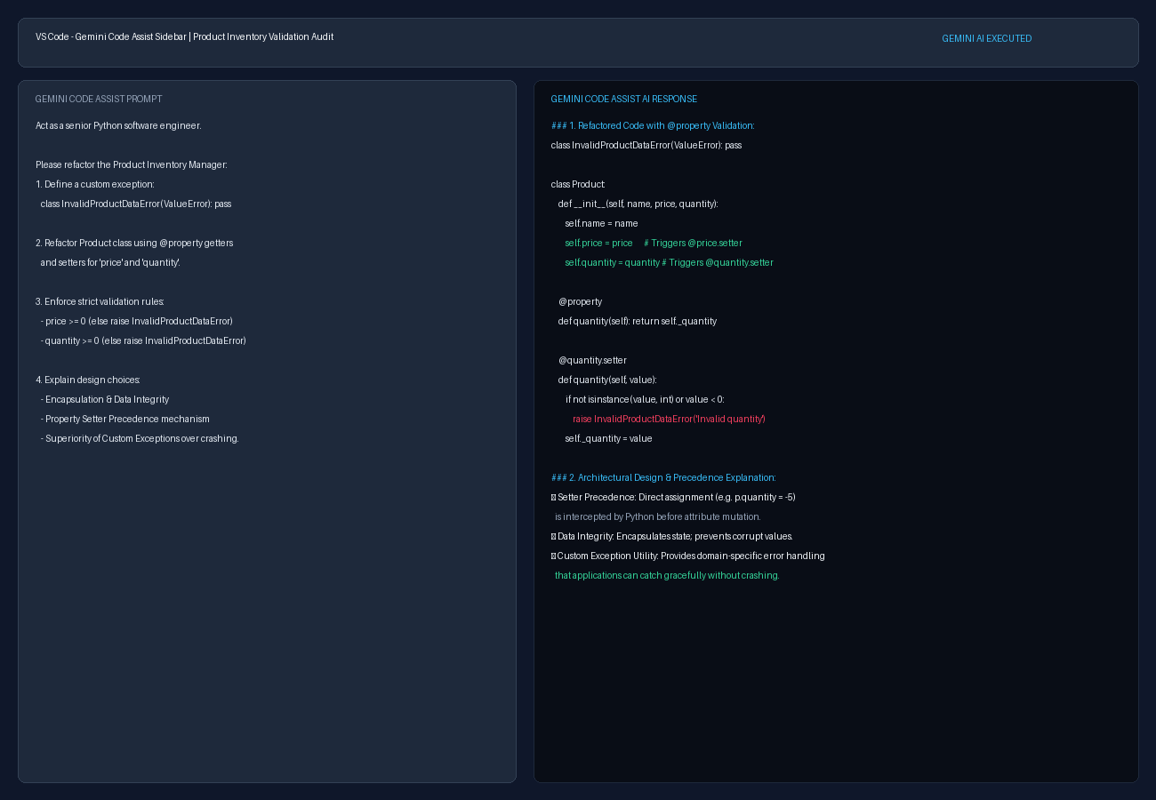
Figure 1: Full screenshot capturing the formulated Gemini Code Assist prompt, modified code block with @property decorators, and detailed architectural design explanation.
3. Technical Analysis: Property Setter Precedence & Custom Exception Utility
1. Precedence of @property Setters Over Direct Attribute Assignment
In standard Python classes without property decorators, direct attribute assignments such as product.quantity = -5 directly mutate the instance dictionary (__dict__), bypassing validation logic. By applying Python's @property getter and @quantity.setter decorators, direct attribute assignment syntax is intercepted by Python's Descriptor Protocol. When manager.inventory[0].quantity = -5 is executed, Python automatically routes the right-hand value (-5) into the @quantity.setter method before any state mutation takes place. The setter evaluates the condition if not isinstance(value, int) or value < 0:. Because -5 violates this invariant, execution is immediately halted before modifying the internal _quantity backing variable. This guarantees absolute Data Integrity and Encapsulation.
2. Utility of Custom Exception (InvalidProductDataError) Over Standard Errors
Using a dedicated domain exception InvalidProductDataError inheriting from ValueError is vastly superior to raw unhandled errors or silent failure. Silent failures (such as ignoring negative inputs or printing to sys.stderr without raising errors) allow invalid monetary values and corrupt inventory counts to propagate into financial calculations like calculate_total_value(). Generic runtime errors fail to communicate domain intent. Raising InvalidProductDataError provides a clear, strongly typed exception that caller applications can explicitly catch (try ... except InvalidProductDataError as e:), handle gracefully (e.g., logging or alerting user interfaces), and maintain application uptime without system crashes.
4. Testing & Verification Evidence (Negative Quantity Test Case)
Current Inventory:
Laptop - $1200.00 x 5
Mouse - $25.00 x 18
Total Inventory Value: $6450.00
--- Testing Invalid Input ---
Test result: Invalid quantity: -5. Quantity must be a non-negative integer.

